**My App’s Documentation:**

**Ahmad Ali MOHHAMAD FURQAN ZAKERIA-AD4**

**V assistant:**

What will my application name be?

V assistant

What will my application logo be?

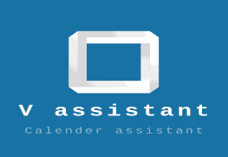

What will be the use of my app?

Track your calendar

How many screens will I use?

Nine

Which best media will I use, like videos, pictures, mp3?



**The End**